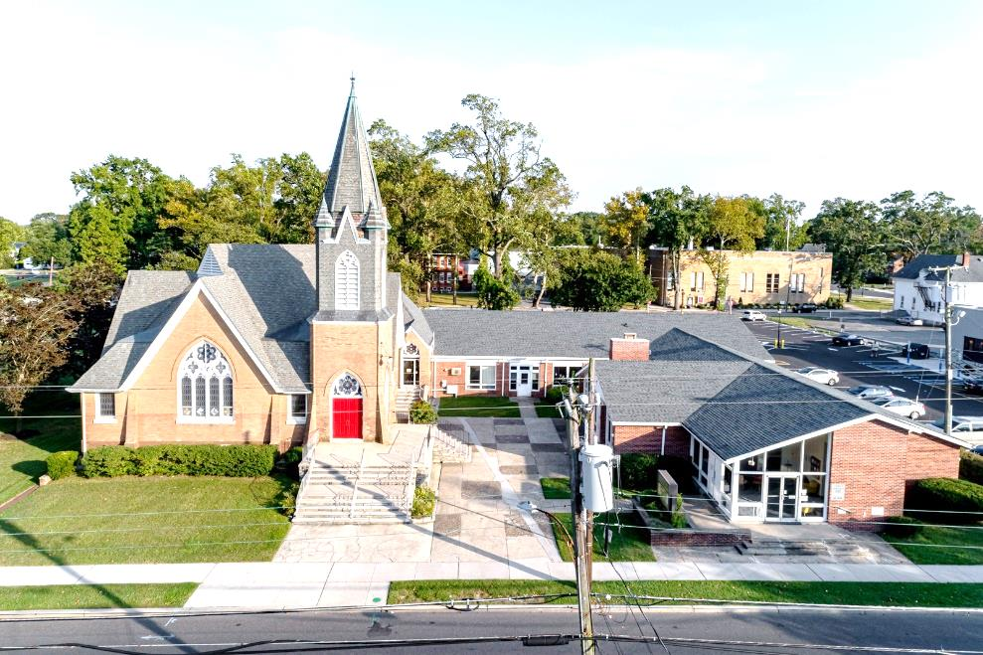

The Presbyterian Church at Hammonton
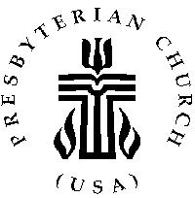

Our vision is to open our doors to all seeking a spiritual home of worship and to carry the light and love of Jesus Christ, our Savior, throughout the community.

MISSION STATEMENT
We are committed to Jesus Christ and the growing of his Church by glorifying God and by proclaiming the good news of the gospel through word and deed. We involve and reach out to our members and our community in Christ’s name through worship, Christian Education, and stewardship to support the mission of our church.

Note: Special thanks to Rev. Dr. Patricia Epprecht for leading us in worship today.

Organist: Cindy Birnbaum
Sunday School Superintendent: Beth Burkett-Rice

2021 2022 2023
ELDERS
Frank Johnson Eric Copenhaver Robert Bauers
Robin Mishkovsky Marylee Kondrach Dorrine Esposito
Beth Burkett Rice Charles Muller Richard Walker

DEACONS
Kris Guldin Elsie Bakley Wendy Copenhaver
Carol Orsi Nancy Foster Ann DiMeo
Becky Villani Margaret Jones Rebecca Lindstrom

Clerk of Session: Beth Burkett-Rice

Church Office: 326 Bellevue Avenue, Hammonton, NJ
Office hours: Tuesday - Thursday 9:30 AM to 12:30 PM
Phone (609) 561-0168 ~ Fax (609) 561-6105
e-mail: office@hammontonpres.org
website: www.hammontonpres.org

November 28, 2021
The 1st Sunday of Advent
VIRTUAL & LIVE SERVICE
11:00am
****************************************************
“Welcome to the Presbyterian Church at Hammonton, we are glad you are able to join us. As we gather for worship feel free to pray and meditate on God’s calling in your life. Be respectful of others around you who might be doing the same, prior and during the Prelude, keeping your voice and conversation soft and to a minimum.”
Peace will come when people live
In friendship, side by side,
And cherish understanding
More than hatred, greed, and pride.
- Amanda Bradley

PRELUDE ~ “O Come, O Come Emmanuel”- R. Koury
“Prepare the Way, O Zion”- D. Paxton
“O Little Town of Bethlehem”- J. Southbridge

~ TIME FOR CENTERING STILLNESS AND SILENCE ~

WELCOME AND ANNOUNCEMENTS

*THE PEACE
Let the people greet one another by staying in their seats and saying: “Peace be with you!”

INTROIT

~ HUMBLY APPROACHING GOD ~

OPENING PRAYER
Break into the rhythm of our lives.
Awaken us to the joy of being here among your children,
our family.
Let us experience your presence, O Lord, in new ways.
That we may know you all the more clearly. Amen.

CALL TO WORSHIP
Something deep inside stirs,
Our hearts awaken
The darkness intensifies the longing --
Yearning for the light,
Hoping for the joy,
Longing for the peace,
Searching for meaning.
Something stirs at Advent --
The memory of Christmas’ past,
The promise of God with us,
God in us,
Setting us free from fear,
Releasing us from sin,
Setting loose a song.

HYMN #2 “Come, Thou Long-Expected Jesus”
LIGHTING OF ADVENT CANDLES- the Orsi Family

CALL TO CONFESSION

PRAYER OF CONFESSION (unison)
God of all times and seasons, how quickly the year spins by and we are caught unprepared for your Advent. We are still recovering from Thanksgiving or the election or the latest crisis or the long list of things to do. The demands on our time seems unending. The tasks seem overwhelming and our energy is draining. Holy God, sing to us in the stillness of this moment of the peace that will rest our souls. Flow into our hearts and show us your peace and presence. Make us new and re-new us for you mission that we too often neglect; the mission to feed the poor on more than canned foods, to heal the sick using more than remote prayers, and to spread the good news of your love in action as well as word. God of all seasons, create a place in our hearts prepared for your birth into our lives.
(Silent confession)

ASSURANCE OF FORGIVENESS

GLORIA PATRI (#579)
Glory be to the Father and to the Son and to the Holy Ghost; as it was in the beginning is now and ever shall be, world without end. Amen.

~ RECEIVING GOD’S WORD ~

CHOIR ANTHEM – “Bring us Hope”

PRAYER OF ILLUMINATION

SCRIPTURE READINGS
Jeremiah 33: 14 - 16 ~Page 699 (OT)
Luke 21: 25 - 36 ~ Page 81 (NT)

MESSAGE ~ “The Day is Coming”
Text: Be on guard so that your hearts are not weighed down with dissipation and drunkenness and the worries of this life, and that day catch you unexpectedly, like a trap. Luke 21:34-35a

~ RESPONDING TO THE WORD ~

HYMN “Holy Child, Come Down from Heaven”
Lawrence Balleine (Tune: Austrian Hymn 8.7.8.7 D #285)

Holy Child, come down from heaven
Light the world with truth and grace.
By the Father’s tender mercies
You made earth, your sacred space.
Hear the names we now ascribe You -
Gentle Savior, Prince of Peace -
As we celebrate your presence
Praying that all conflicts cease.
In this gift of Christ - Emmanuel
We are offered God’s embrace
With a message of forgiveness
Filling hearts with truth and grace.
So the Father, Son, and Spirit
Triune God - we offer praise
As we render lives of service
Being grateful all our days.

JOYS AND CONCERNS OF THE CHURCH

PASTORAL PRAYER & LORD’S PRAYER
Our Father, who art in heaven, hallowed be Thy name. Thy kingdom come, thy will be done, on earth as it is in heaven. Give us this day our daily bread; and forgive our debts as we forgive our debtors; and lead us not into temptation, but deliver us from evil. For Thine is the kingdom and the power and the glory, forever. Amen.

THE OFFERING OF OUR GIFTS AND OURSELVES

OFFERTORY ~ “Love Came Down at Christmas”

OFFERTORY PRAYER

~ GOING IN GOD’S NAME ~

*HYMN #536 ~ “Lord, Make Us More Holy”

*THE CHARGE AND BENEDICTION

POSTLUDE~ “And There Was a Star” – D. Paxton

OUR WORSHIP HAS ENDED, LET OUR
SERVICE BEGIN

*Signifies stand if comfortable

CHURCH EVENTS
>>>THIS WEEK:
Monday-11/29:
9:00 AM Clothing Closet service hours
9:00 to Noon
Tuesday-11/30
9:00 AM Clothing Closet service hours
9:00 to Noon
Wednesday-12/01
9:00 AM Clothing Closet service hours
9:00 to Noon
Friday -12/03
12:30PM Bells
______________________________________________
>>UPCOMING:
Sunday-12/05 Church Christmas Party
3:00 PM Hosted by Jane and Frank Johnson
106 Birch Drive
Hammonton, NJ
You do not have to attend the Philadelphia Boy's Choir
concert to go to the Party. All are welcome. Sign up sheet
on bulletin board in Christian Ed hallway. For more
information contact Donna Brown at 609-561-7630.

Monday-12/06
9:00 AM Clothing Closet service hours
9:00 to Noon
Tuesday-12/07:
9:00 AM Clothing Closet service hours
9:00 to Noon
Wednesday-12/08
9:00 AM Clothing Closet service hours
9:00 to Noon
Friday -12/10
12:30PM Bells

______________________________________________
BIRTHDAYS:
Nov.28 Lillian Chalk
______________________________________________
ANNIVERSARIES:

No happy couples this week

SERVING YOU TODAY:
Liturgist: Albert Brown III

Ushers: Richard Walker, Captain
Richard Gibson
Bob Rebek
Millie Walker

**Children’s Church Becky Villani
Next week: Dorrine Esposito

